Exercise 1: Configuring a Basic Spring Application
BookRepository.java
package com.library.repository;

public class BookRepository {

public void display() {
System.out.println("BookRepository Bean Created");
}
}

ApplicationContext.xml
<?xml version="1.0" encoding="UTF-8"?>

<beans xmlns="http://www.springframework.org/schema/beans"
xmlns:xsi="httap://www.w3.org/2001/XMLSchema-instance"
xsi:schemaLocation="
http://www.springframework.org/schema/beans
https://www.springframework.org/schema/beans/spring-beans.xsd">

<bean id="bookRepository"
class="com.library.repository.BookRepository"/>

<bean id="bookService"
class="com.library.service.BookService"/>

</beans>

pom.xml
<project xmlns="http://maven.apache.org/POM/4.0.0"
xmlns:xsi="http://www.w3.org/2001/XMLSchema-instance"
xsi:schemaLocation="http://maven.apache.org/POM/4.0.0
http://maven.apache.org/xsd/maven-4.0.0.xsd">

<modelVersion>4.0.0</modelVersion>

<groupId>com.library</groupId>
<artifactId>LibraryManagement</artifactId>
<version>1.0-SNAPSHOT</version>
<packaging>jar</packaging>

<name>LibraryManagement</name>

<dependencies>

<dependency>
<groupId>org.springframework</groupId>
<artifactId>spring-context</artifactId>
<version>5.3.30</version>
</dependency>

<dependency>
<groupId>junit</groupId>
<artifactId>junit</artifactId>
<version>3.8.1</version>
<scope>test</scope>
</dependency>

</dependencies>

</project>

BookService.java
package com.library.service;

public class BookService {

public void display() {
System.out.println("BookService Bean Created");
}
}

App.java (Main Class)
package com.library;

import org.springframework.context.ApplicationContext;
import org.springframework.context.support.ClassPathXmlApplicationContext;

import com.library.repository.BookRepository;
import com.library.service.BookService;

public class App {

public static void main(String[] args) {

ApplicationContext context =
new ClassPathXmlApplicationContext("applicationContext.xml");

BookService service =
(BookService) context.getBean("bookService");

BookRepository repository =
(BookRepository) context.getBean("bookRepository");

service.display();
repository.display();

System.out.println("Spring Configuration Successful!");
}
}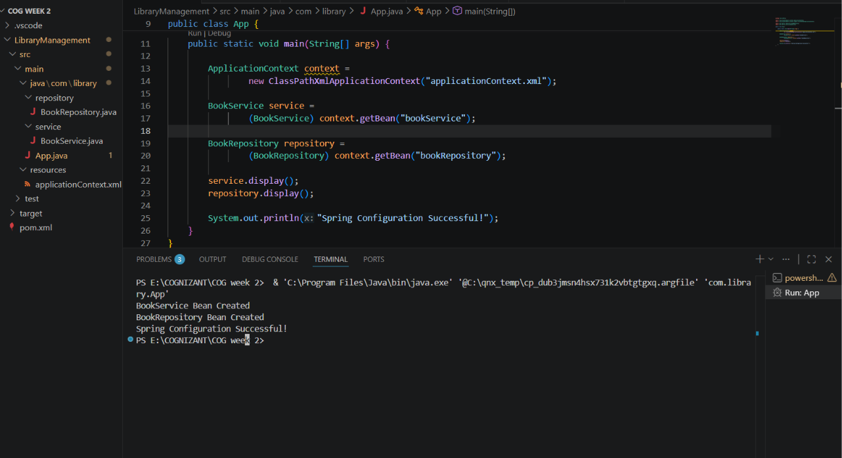

Exercise 2: Implementing Dependency Injection
BookService.java

package com.library.service;

import com.library.repository.BookRepository;

public class BookService {

private BookRepository bookRepository;

public void setBookRepository(BookRepository bookRepository) {
this.bookRepository = bookRepository;
}

public void display() {
System.out.println("BookService Bean Created");
bookRepository.display();
}
}
applicationContext.xml
<?xml version="1.0" encoding="UTF-8"?>

<beans xmlns="http://www.springframework.org/schema/beans"
xmlns:xsi="http://www.w3.org/2001/XMLSchema-instance"
xsi:schemaLocation="
http://www.springframework.org/schema/beans
https://www.springframework.org/schema/beans/spring-beans.xsd">

<bean id="bookRepository"
class="com.library.repository.BookRepository"/>

<bean id="bookService"
class="com.library.service.BookService">

<property name="bookRepository"
ref="bookRepository"/>

</bean>

</beans>
App.java
package com.library;

import org.springframework.context.ApplicationContext;
import org.springframework.context.support.ClassPathXmlApplicationContext;

import com.library.repository.BookRepository;
import com.library.service.BookService;

public class App {

public static void main(String[] args) {

ApplicationContext context =
new ClassPathXmlApplicationContext("applicationContext.xml");

BookService service =
(BookService) context.getBean("bookService");

service.display();

System.out.println("Spring Configuration Successful!");
}
}
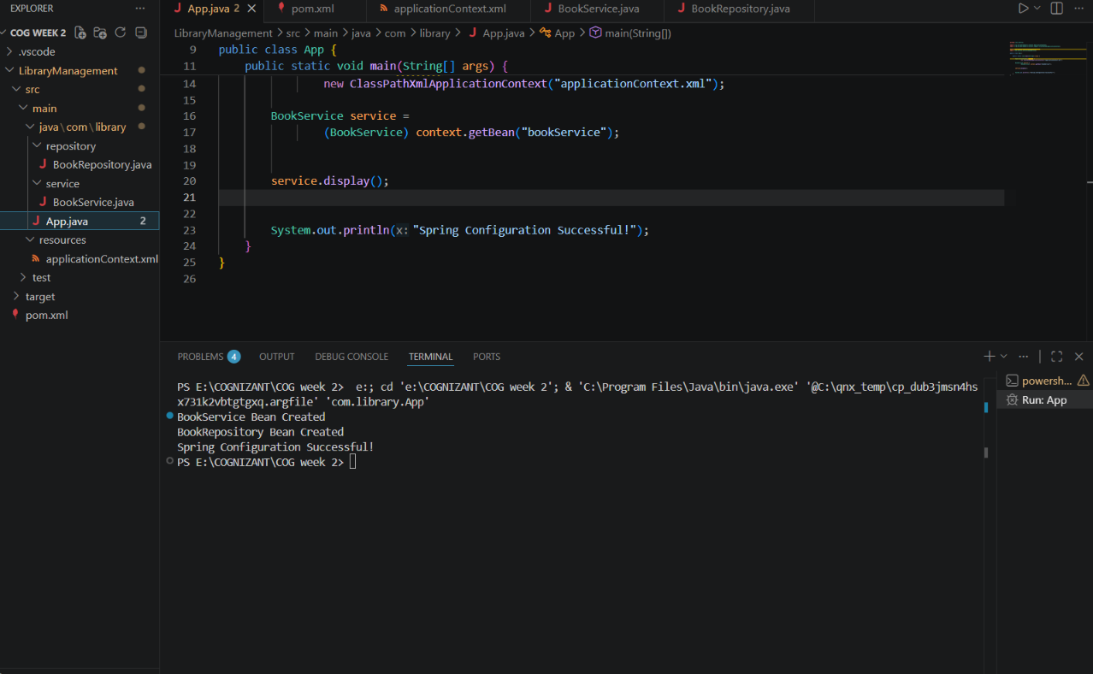

Exercise 3: Implementing Logging with Spring AOP
LoggingAspect.java
package com.library.aspect;

public class LoggingAspect {

public void beforeMethod() {
System.out.println("AOP Log: Method execution started");
}

public void afterMethod() {
System.out.println("AOP Log: Method execution completed");
}
}

App.java

package com.library;

import org.springframework.context.ApplicationContext;
import org.springframework.context.support.ClassPathXmlApplicationContext;

import com.library.repository.BookRepository;
import com.library.service.BookService;

public class App {

public static void main(String[] args) {

ApplicationContext context =
new ClassPathXmlApplicationContext("applicationContext.xml");

BookService service =
(BookService) context.getBean("bookService");

service.display();

System.out.println("Spring Configuration Successful!");
}
}

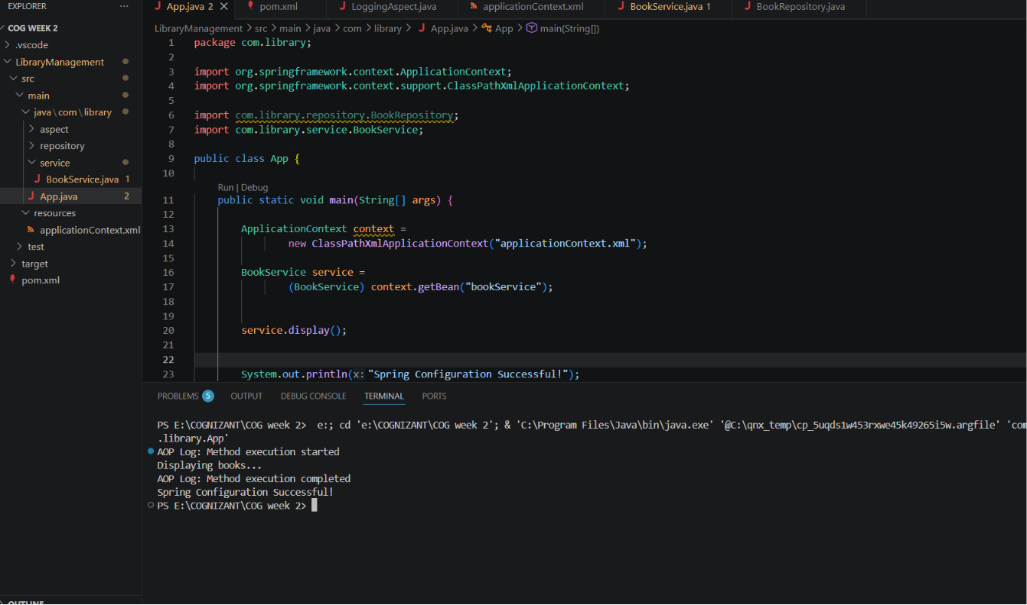

Exercise 4: Creating and Configuring a Maven Project
Pom.xml
<project xmlns="http://maven.apache.org/POM/4.0.0"
xmlns:xsi="http://www.w3.org/2001/XMLSchema-instance"
xsi:schemaLocation="http://maven.apache.org/POM/4.0.0
http://maven.apache.org/xsd/maven-4.0.0.xsd">

<modelVersion>4.0.0</modelVersion>

<groupId>com.library</groupId>
<artifactId>LibraryManagement</artifactId>
<version>1.0-SNAPSHOT</version>
<packaging>jar</packaging>

<name>LibraryManagement</name>

<properties>
<maven.compiler.source>1.8</maven.compiler.source>
<maven.compiler.target>1.8</maven.compiler.target>
</properties>

<dependencies>

<!-- Spring Context -->
<dependency>
<groupId>org.springframework</groupId>
<artifactId>spring-context</artifactId>
<version>5.3.30</version>
</dependency>

<!-- Spring AOP -->
<dependency>
<groupId>org.springframework</groupId>
<artifactId>spring-aop</artifactId>
<version>5.3.30</version>
</dependency>

<!-- Spring Web MVC -->
<dependency>
<groupId>org.springframework</groupId>
<artifactId>spring-webmvc</artifactId>
<version>5.3.30</version>
</dependency>

<!-- AspectJ Weaver -->
<dependency>
<groupId>org.aspectj</groupId>
<artifactId>aspectjweaver</artifactId>
<version>1.9.21</version>
</dependency>

<!-- JUnit -->
<dependency>
<groupId>junit</groupId>
<artifactId>junit</artifactId>
<version>3.8.1</version>
<scope>test</scope>
</dependency>

</dependencies>

<build>
<plugins>

<plugin>
<groupId>org.apache.maven.plugins</groupId>
<artifactId>maven-compiler-plugin</artifactId>
<version>3.11.0</version>

<configuration>
<source>1.8</source>
<target>1.8</target>
</configuration>
</plugin>

</plugins>
</build>

</project>
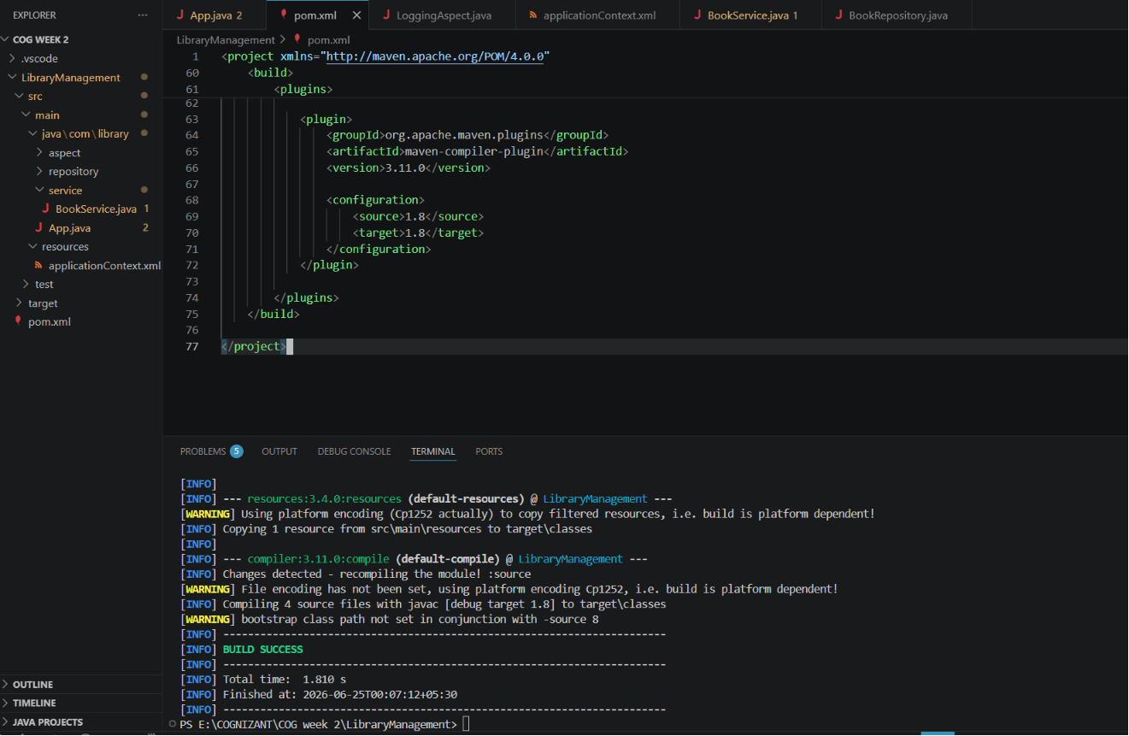
Exercise 5: Configuring the Spring IoC Container
App.java
package com.library;

import org.springframework.context.ApplicationContext;
import org.springframework.context.support.ClassPathXmlApplicationContext;

import com.library.service.BookService;

public class App {

public static void main(String[] args) {

ApplicationContext context =
new ClassPathXmlApplicationContext("applicationContext.xml");

BookService service =
context.getBean("bookService", BookService.class);

service.display();

System.out.println("IoC Container Successful!");
}
}
BookRepository

package com.library.service;

import com.library.repository.BookRepository;

public class BookService {

private BookRepository bookRepository;

public void setBookRepository(BookRepository bookRepository) {
this.bookRepository = bookRepository;
}

public void display() {
bookRepository.showBook();
System.out.println("Book Service Running");
}
}
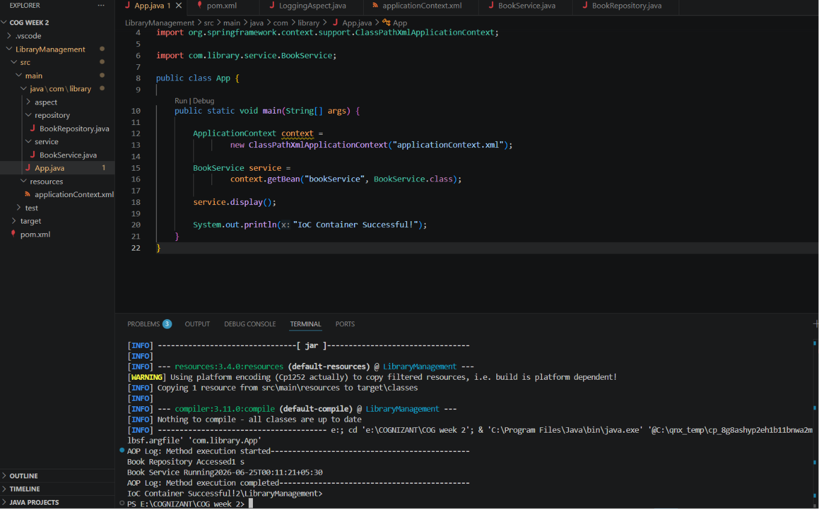
Exercise 6: Configuring Beans with Annotations
BookRepository.java
package com.library.repository;

import org.springframework.stereotype.Repository;

@Repository
public class BookRepository {

public void showBook() {
System.out.println("Book Repository Accessed");
}
}
BookService.java

package com.library.service;

import org.springframework.beans.factory.annotation.Autowired;
import org.springframework.stereotype.Service;

import com.library.repository.BookRepository;

@Service
public class BookService {

@Autowired
private BookRepository bookRepository;

public void display() {
bookRepository.showBook();
System.out.println("Book Service Running");
}
}
applicationContext.xml

<?xml version="1.0" encoding="UTF-8"?>

<beans xmlns="http://www.springframework.org/schema/beans"
xmlns:xsi="http://www.w3.org/2001/XMLSchema-instance"
xmlns:context="http://www.springframework.org/schema/context"
xmlns:aop="http://www.springframework.org/schema/aop"
xsi:schemaLocation="
http://www.springframework.org/schema/beans
https://www.springframework.org/schema/beans/spring-beans.xsd
http://www.springframework.org/schema/context
https://www.springframework.org/schema/context/spring-context.xsd
http://www.springframework.org/schema/aop
https://www.springframework.org/schema/aop/spring-aop.xsd">

<!-- Scan all packages under com.library -->
<context:component-scan base-package="com.library"/>

<!-- AOP Aspect -->
<bean id="loggingAspect"
class="com.library.aspect.LoggingAspect"/>

<aop:config>

<aop:aspect ref="loggingAspect">

<aop:pointcut
id="serviceMethods"
expression="execution(* com.library.service.*.*(..))"/>

<aop:before
pointcut-ref="serviceMethods"
method="beforeMethod"/>

<aop:after
pointcut-ref="serviceMethods"
method="afterMethod"/>

</aop:aspect>

</aop:config>

</beans>
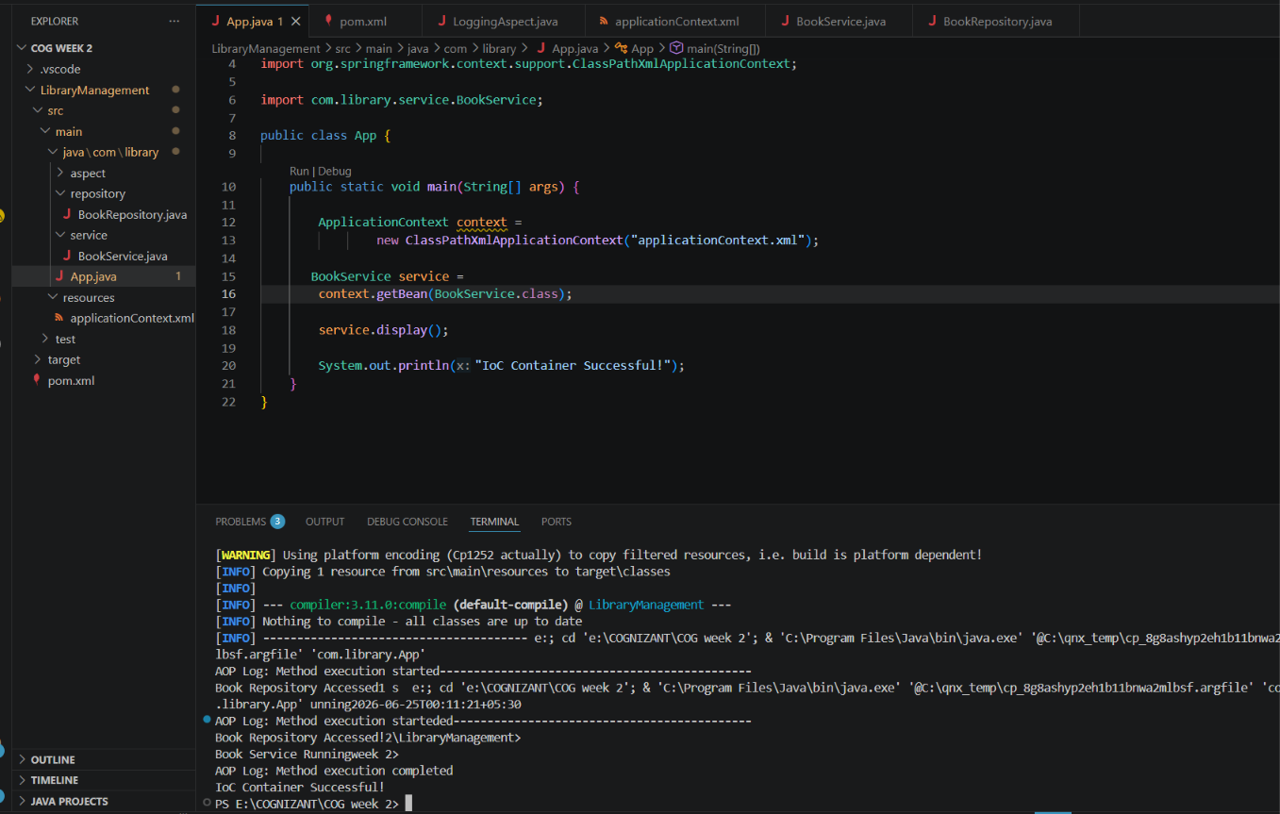
Exercise 7: Implementing Constructor and Setter Injection
BookService.java
package com.library.service;

import com.library.repository.BookRepository;

public class BookService {

private BookRepository bookRepository;

// Constructor Injection
public BookService(BookRepository bookRepository) {
this.bookRepository = bookRepository;
System.out.println("Constructor Injection Successful");
}

// Setter Injection
public void setBookRepository(BookRepository bookRepository) {
this.bookRepository = bookRepository;
System.out.println("Setter Injection Successful");
}

public void display() {
bookRepository.showBook();
System.out.println("Book Service Running");
}
}
applicationContext.xml

<?xml version="1.0" encoding="UTF-8"?>

<beans xmlns="http://www.springframework.org/schema/beans"
xmlns:xsi="http://www.w3.org/2001/XMLSchema-instance"
xmlns:aop="http://www.springframework.org/schema/aop"
xsi:schemaLocation="
http://www.springframework.org/schema/beans
https://www.springframework.org/schema/beans/spring-beans.xsd
http://www.springframework.org/schema/aop
https://www.springframework.org/schema/aop/spring-aop.xsd">

<bean id="bookRepository"
class="com.library.repository.BookRepository"/>

<bean id="bookService"
class="com.library.service.BookService">

<!-- Constructor Injection -->
<constructor-arg ref="bookRepository"/>

<!-- Setter Injection -->
<property name="bookRepository"
ref="bookRepository"/>

</bean>

<bean id="loggingAspect"
class="com.library.aspect.LoggingAspect"/>

<aop:config>
<aop:aspect ref="loggingAspect">

<aop:pointcut
id="serviceMethods"
expression="execution(* com.library.service.*.*(..))"/>

<aop:before
pointcut-ref="serviceMethods"
method="beforeMethod"/>

<aop:after
pointcut-ref="serviceMethods"
method="afterMethod"/>

</aop:aspect>
</aop:config>

</beans>
App.java
package com.library;

import org.springframework.context.ApplicationContext;
import org.springframework.context.support.ClassPathXmlApplicationContext;

import com.library.service.BookService;

public class App {

public static void main(String[] args) {

ApplicationContext context =
new ClassPathXmlApplicationContext("applicationContext.xml");

BookService service =
context.getBean("bookService", BookService.class);

service.display();

System.out.println("Constructor and Setter Injection Successful!");
}
}
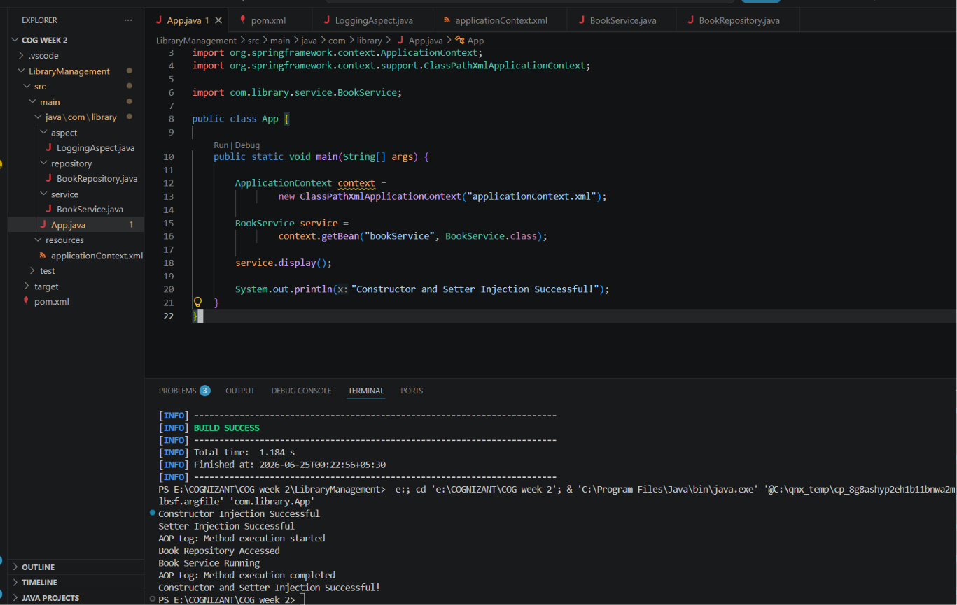
Exercise 8: Implementing Basic AOP with Spring
App.java
package com.library;

import org.springframework.context.ApplicationContext;
import org.springframework.context.support.ClassPathXmlApplicationContext;

import com.library.service.BookService;

public class App {

public static void main(String[] args) {

ApplicationContext context =
new ClassPathXmlApplicationContext("applicationContext.xml");

BookService service =
context.getBean("bookService", BookService.class);

service.display();

System.out.println("Constructor and Setter Injection Successful!");
}
}
LoggingAspect.java

package com.library.aspect;

public class LoggingAspect {

public void beforeMethod() {
System.out.println("AOP Log: Method execution started");
}

public void afterMethod() {
System.out.println("AOP Log: Method execution completed");
}
}
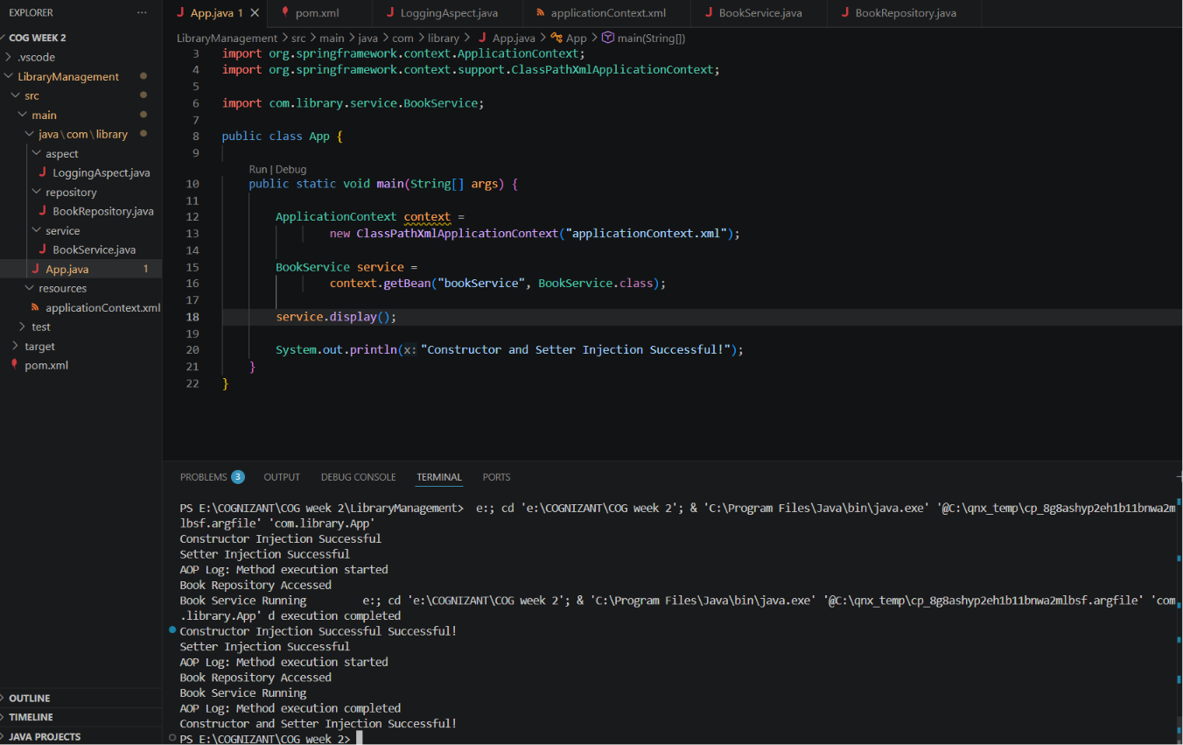
Exercise 9: Creating a Spring Boot Application
